Miguel Fernandez
1/25/26
Module 2.2 Assignment

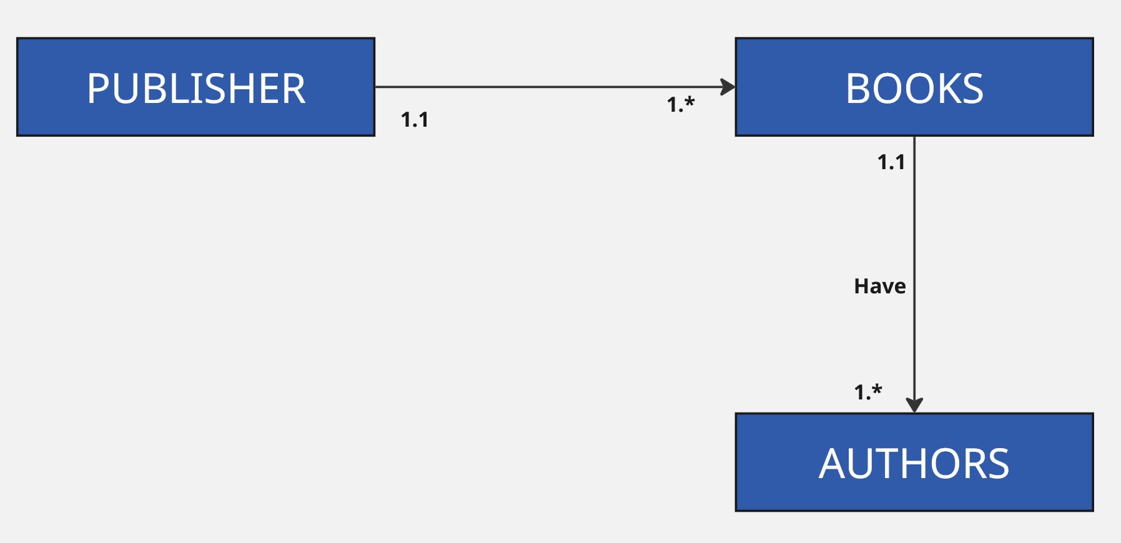

https://github.com/concord808030-tech/CSD310-300O-

